Appendix for gpac



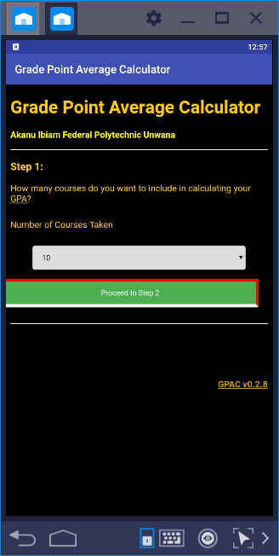

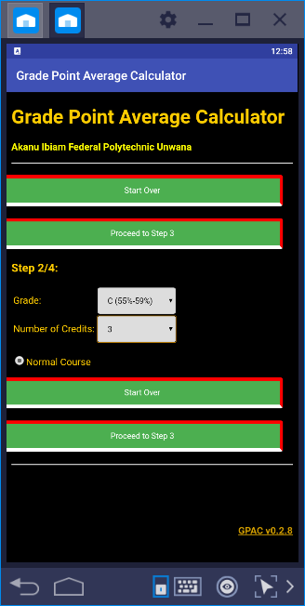

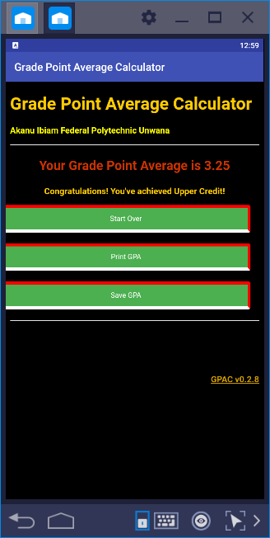

Index.php

<html>

<head>

<title>GPA Calculator</title>

</head>

<body bgcolor="green">

<h1 align="center"><font color="white">Grade Point Average Calculator </font></h1>

<p align="center"><font color="white" size=10>Design and Implementation of a Mobile GPA Calculator</FONT></p>

<h2 align="center"><font color="white">by</font></h2>

<h2 align="center"><font color="white">OJATING SYLVESTER ONGHIRI</font></h2>

<h2 align="center"><font color="white">2017/ND/24871/CS</font></h2>

<p align="center"><font color="yellow" size=10><a href="gpa.php">Proceed</a></FONT></p>

</body>

<html>

**gpa.php**

<?php

error_reporting(E_ALL ^ E_NOTICE);

//system variables

$GPACFileName = "gpa.php"; //The name of the file should go here. NOTE: For GPAC to run correctly, THIS IS THE ONLY LINE YOU SHOULD MODIFY!!!

//version variables - for debugging purposes, PLEASE DO NOT MODIFY!

$GPACVersionNumber = "v0.2.8";

$GPACVersionStatus = "alpha";

$GPACCopyrightYear = 2019;

/***************************************************/

if($_GET['source']) { //display source if requested

$file = file_get_contents($GPACFileName);

header("Content-Type: text/plain");

echo $file;

exit(); //stop script execution

}

//execute commands (available for user after gpa calculation)

if ($_POST['reset']) { header ("Location: $GPACFileName"); }

if ($_POST['save']) { setcookie ("gpa", $_POST['gpa'], time()+60*60*24*365); }

?>

<!DOCTYPE html PUBLIC "-//W3C//DTD XHTML 1.0 Transitional//EN" "http://www.w3.org/TR/xhtml1/DTD/xhtml1-transitional.dtd">

<html xmlns="http://www.w3.org/1999/xhtml">

<?php

if($_POST['print']) { //display and print gpa in a printer-friendly format

?>

<head><title>Grade Point Average Calculator</title>

<link rel="stylesheet" type="text/css" href="mystyle.css">

</head>

<body onLoad="window.print();">

<h1>Grade Point Average Calculator</h1>

<p><b>Akanu Ibiam Federal Polytechnic Unwana</b></p>

<hr />

<div align='center'>

<h2>Your Grade Point Average is <?php echo $_POST['gpa']; ?></h2>

<?php

if ($_POST['gpa']>=3.5) {

echo "<p><b>Congratulations! You've achieved Distinction!</b></p>";

}

if ($_POST['gpa']>=3.0 && $_POST['gpa']<3.5) {

echo "<p><b>Congratulations! You've achieved Upper Credit!</b></p>";

}

if ($_POST['gpa']>=2.5 && $_POST['gpa']<3.0) {

echo "<p><b>Congratulations! You've achieved Lower Credit!</b></p>";

}

if ($_POST['gpa']>=2.0 && $_POST['gpa']<2.5) {

echo "<p><b>Congratulations! You made Pass!</b></p>";

}

if ($_POST['gpa']<2.0) {

echo "<p><b>Sorry, You Failed!</b></p>";

}

?>

</div>

<hr />

<p align="right">GPAC <?php echo $GPACVersionNumber; ?>

<br />Copyright &copy; <?php echo $GPACCopyrightYear; ?> Ojating Syslvester O.</p>

</body>

</html>

<?php

exit();

} // /print

?>

<head>

<meta http-equiv="Content-Type" content="text/html; charset=iso-8859-1" />

<meta name="description" content="A convenient grade point average calculator, based on a typical high school system." />

<meta name="keywords" content="education, school, grades, grade, gpa, grade point average, calculator, free, open-source, open source" />

<meta name="author" content="Ojating Syslvester O." />

<link rel="shortcut icon" href="favicon.ico" />

<title>Grade Point Average Calculator</title>

<link rel="stylesheet" type="text/css" href="mystyle.css">

<script type="text/javascript" language="javascript">

function moreInfo() {

proceed = confirm("Grade Point Average Calculator (GPAC)\n-<?php echo $GPACVersionNumber; ?> (<?php echo $GPACVersionStatus; ?>)-\n----------\n(For more information, click \'Cancel\')\n----------\nCopyright © <?php echo $GPACCopyrightYear; ?> Ojating Syslvester O.");

if(proceed==false) {

window.open('<?php echo $GPACFileName; ?>?info=true','info','status=yes,scrollbars=yes,resizable=yes,width=675,height=620');

}

}

</script>

<style type="text/css">

<!--

body,td,th {

font-family: Arial;

color: #FFCC00;

}

body {

background-color: #000000;

}

a:link {

color: #CC9900;

}

a:visited {

color: #CC6600;

}

.subtitle {

color: #FFFF00;

font-weight: bold;

font-size: medium;

}

.small {

font-size: small;

}

.results {

font-size: x-large;

color: #CC3300;

font-weight: bold;

}

acronym:hover {

cursor: help;

}

-->

</style>

</head>

<?php

if($_GET['info']) {

?>

<body>

<h2>Grade Point Average Calculator</h2>

<p><b><?php echo $GPACVersionNumber; ?> (<?php echo $GPACVersionStatus; ?>)</b></p>

<p><i>GPAC is a convenient grade point average calculator, based on a typical Polytechnic school system.</i></p>

<p>Licensed under the <a href="http://www.gnu.org/copyleft/gpl.html">GNU General Public License</a></p>

<blockquote>

This program is free software; you can redistribute it and/or<br />

modify it under the terms of the GNU General Public License<br />

as published by the Free Software Foundation; either version 2<br />

of the License, or (at your option) any later version.<br />

<br />

This program is distributed in the hope that it will be useful,<br />

but WITHOUT ANY WARRANTY; without even the implied warranty of<br />

MERCHANTABILITY or FITNESS FOR A PARTICULAR PURPOSE. See the<br />

GNU General Public License for more details.<br />

<br />

<i><a href="http://www.gnu.org/licenses/gpl.txt">View full text of license</a></i>

</blockquote>

<p>This script is <a href="http://www.opensource.org/docs/definition.php">open source</a>. The source code of the Grade Point Average Calculator is available <br />for download from the <a href="http://sourceforge.net/projects/gpa/" title="Project Homepage">project homepage</a>.</p>

<p>GPAC markup has been coded to be valid XHTML 1.0 Transitional.

<br />The document's <acronym title="Cascading Style Sheets">CSS</acronym> also passes validation.</p>

<p>

<!--Sourceforge logo code-->

<a href="http://sourceforge.net"><img src="http://sflogo.sourceforge.net/sflogo.php?group_id=159462&amp;type=1" width="88" height="31" border="0" alt="SourceForge.net Logo" /></a>

<!--/Sourceforge logo code-->

&nbsp;|&nbsp;

<!-- GPL License (image via http://gtmcknight.com/buttons/)-->

<a href="http://www.gnu.org/copyleft/gpl.html">

<img src="http://gpa.sourceforge.net/gnugpl.png" alt="Licensed under the GNU General Public License" border="0" height="15" width="80" />

</a>

<!-- /GPL License -->

&nbsp;|&nbsp;

<!--Valid XHTML-->

<a href="http://validator.w3.org/check?uri=referer">

<img src="http://www.w3.org/Icons/valid-xhtml10" alt="Valid XHTML 1.0 Transitional" height="31" width="88" border="0" />

</a>

<!--/Valid XHTML-->

&nbsp;|&nbsp;

<!--Valid CSS-->

<a href="http://jigsaw.w3.org/css-validator/check/referer">

<img style="border:0;width:88px;height:31px" src="http://jigsaw.w3.org/css-validator/images/vcss" alt="Valid CSS!" border="0" />

</a>

<!--/Valid CSS-->

&nbsp;|&nbsp;

<!--Open Source-->

<a href="http://www.opensource.org/docs/definition.php"><img src="http://www.opensource.org/trademarks/opensource/web/opensource-55x48.png" alt="Open Source" border="0" width="55" height="48" /></a>

<!--/Open Source-->

&nbsp;|&nbsp;

<a href="<?php echo $GPACFileName; ?>?source=true">View source code</a>

</p>

<p>Copyright &copy; <?php echo $GPACCopyrightYear; ?> <a href="" title="Contact Ojating Syslvester O.">Ojating Syslvester O.</a></p>

</body>

</html>

<?php

exit();

} // /info

if ($_POST['save']) {

echo "<body onLoad=\"alert('Your GPA was saved successfully!')\">";

} else {

echo "<body>"; }

?>

<h1>Grade Point Average Calculator</h1>

<p class="subtitle">Akanu Ibiam Federal Polytechnic Unwana</p>

<?php

$courses = $_POST['courses'];

if (isset($courses)) {

/*

For the following variables,

$cc - current step

$tc = total steps

$nc = next step

*/

$cc = $_POST['cc'] + 1;

$tc = $courses + 1;

$nc = $cc + 1;

$grade_temp = $_POST['grade'];

$credits_temp = $_POST['credits'];

$course_temp = $_POST['course'];

$credits = $_POST['fcredits'];

$points = $_POST['fpoints'];

$credits = $credits + $credits_temp;

$points_temp = $grade_temp*$credits_temp*$course_temp;

$points = $points + $points_temp;

if ($cc==$tc) { $submit = "Calculate GPA!";} // ..=on the last step

else { $submit = "Proceed to Step $nc";}

if ($cc>$tc) { //means all steps have been completed

$gpa = $points / $credits;

echo "<hr /><div align='center'><p class='results'>Your Grade Point Average is $gpa</p>";

if ($gpa>=3.5) {

echo "<p><b>Congratulations! You've achieved Distinction!</b></p>";

}

if ($gpa>=3.0 && $gpa<3.5) {

echo "<p><b>Congratulations! You've achieved Upper Credit!</b></p>";

}

if ($gpa>=2.5 && $gpa<3.0) {

echo "<p><b>Congratulations! You've achieved Lower Credit!</b></p>";

}

if ($gpa>=2.0 && $gpa<2.5) {

echo "<p><b>Congratulations! You made Pass!</b></p>";

}

if ($gpa<2.0) {

echo "<p><b>Sorry, You Failed!</b></p>";

}

$old = $HTTP_COOKIE_VARS["gpa"];

if (isset($old)) { //show change if gpa has been previously saved

$diff = abs($gpa - $old);

if ($gpa>$old) {

echo "<p class='small'><b><i>Good job! This score is an improvement of $diff points compared to your older <acronym title='Grade Point Average'>GPA</acronym>.</i></b></p>";

}

if ($gpa<$old) {

echo "<p class='small'><b><i>Your previous <acronym title='Grade Point Average'>GPA</acronym> was better by $diff points.</i></b></p>";

}

}

echo "<p><form action='$GPACFileName' method='post' name='formInput' id='formInput'>

<input name='gpa' type='hidden' id='gpa' value='$gpa' />

<input style='margin-right:16px' type='submit' name='reset' value='Start Over' /> <input style='margin-right:16px' type='submit' name='print' value='Print GPA' /> <input style='margin-right:16px' type='submit' name='save' value='Save GPA' />

</form></p></div>";

} else { //steps 2 through last

echo "<hr /><form action='$GPACFileName' method='post' name='formInput' id='formInput'>

<input name='courses' type='hidden' id='courses' value='$courses' />

<input name='cc' type='hidden' id='cc' value='$cc' />

<input name='fcredits' type='hidden' id='fcredits' value='$credits' />

<input name='fpoints' type='hidden' id='fpoints' value='$points' />

<input style='margin-right:16px' type='submit' name='reset' value='Start Over' />

<input style='margin-right:16px' type='submit' name='submit' value='$submit' />

<h3>Step $cc/$tc:</h3>";

?>

<table border='0'><tr>

<td>Grade:</td>

<td><select name='grade' size='1' id='grade'>

<option value='4.0'>A (75%-100%)</option>

<option value='3.5'>AB (70%-74%)</option>

<option value='3.25'>B (65%-69%)</option>

<option value='3.0'>BC (60%-64%)</option>

<option value='2.75'>C (55%-59%)</option>

<option value='2.5'>CD (50%-54%)</option>

<option value='2.25'>D (45%-49%)</option>

<option value='2.0'>E (40%-44%)</option>

<option value='0'>F (<60%)</option>

</select></td>

</tr><tr>

<td>Number of Credits: </td>

<td><select name='credits' size='1' id='credits'>

<option value='1.0'>1</option>

<option value='2.0' selected='selected'>2</option>

<option value='3.0'>3</option>

<option value='4.0'>4</option>

<option value='5.0'>5</option>

<option value='6.0'>6</option>

</select></td>

</tr></table>

<p>

<input name='course' type='radio' value='1' checked="checked" />Normal Course

</p>

<?php

echo "

<p>

<input style='margin-right:16px' type='submit' name='reset' value='Start Over' />

<input style='margin-right:16px' type='submit' name='submit' value='$submit' />

</p>

</form>";

} //end of steps 2-last

} else {

if ($_POST['save']) { //if saved, a page similar to results page is displayed

$gpa = $_POST['gpa'];

echo "<hr /><div align='center'><p class='results'>Your Grade Point Average is $gpa</p>";

if ($gpa>=3.5) {

echo "<p><b>Congratulations! You've achieved Distinction!</b></p>";

}

if ($gpa>=3.0 && $gpa<3.5) {

echo "<p><b>Congratulations! You've achieved Upper Credit!</b></p>";

}

if ($gpa>=2.5 && $gpa<3.0) {

echo "<p><b>Congratulations! You've achieved Lower Credit!</b></p>";

}

if ($gpa>=2.0 && $gpa<2.5) {

echo "<p><b>Congratulations! You made Pass!</b></p>";

}

if ($gpa<2.0) {

echo "<p><b>Sorry, You Failed!</b></p>";

}

echo "<p><form action='$GPACFileName' method='post' name='formInput' id='formInput'>

<input name='gpa' type='hidden' id='gpa' value='$gpa' />

<input style='margin-right:16px' type='submit' name='reset' value='Start Over' /> <input style='margin-right:16px' type='submit' name='print' value='Print GPA' /> <input style='margin-right:16px' type='submit' name='save' value='Save GPA' />

</form></p></div>";

} else { //if on step 1

?>

<hr />

<h3>Step 1:</h3>

<form action='<?php echo $GPACFileName; ?>' method='post' name='formCourseNumber' id='formCourseNumber'>

<input name='cc' type='hidden' id='cc' value='1' />

<p>How many courses do you want to include in calculating your <acronym title='Grade Point Average'>GPA</acronym>?</p>

<div class="row">

<div class="col-25">

<label for="fname">Number of Courses Taken</label>

</div>

<div class="col-75">

<blockquote>

<select name='courses' size='1' id='courses'>

<option value='1'>1</option>

<option value='2'>2</option>

<option value='3'>3</option>

<option value='4'>4</option>

<option value='5'>5</option>

<option value='5'>5</option>

<option value='6'>6</option>

<option value='7'>7</option>

<option value='8'>8</option>

<option value='9'>9</option>

<option value='10' selected='selected'>10</option>

<option value='11'>11</option>

<option value='12'>12</option>

<option value='13'>13</option>

<option value='14'>14</option>

<option value='15'>15</option>

<option value='16'>16</option>

<option value='17'>17</option>

<option value='18'>18</option>

<option value='19'>19</option>

<option value='20'>20</option>

</select>

</blockquote>

</div>

</div>

<div class="row">

<input style='margin-right:16px' type="submit" name='proceed' value="Proceed to Step 2">

</div>

</form>

<?php

} //end step 1

} //end if($courses)

?>

<!--footer-->

<hr />

<br />

<br />

<br />

<br />

<p>

<noscript>

&nbsp;|&nbsp;

<a href="<?php echo $GPACFileName; ?>?info=true" title="More Info">About GPAC</a>

</noscript>

</p>

<div align="right">

<p><b><a href="javascript:moreInfo()">GPAC <?php echo $GPACVersionNumber; ?></a></b></p>

</div>

</body>

</html>

**Mystyle.css**

/* Style inputs, select elements and textareas */

input[type=text], select, textarea{

width: 100%;

padding: 12px;

border: 1px solid #ccc;

border-radius: 4px;

box-sizing: border-box;

resize: vertical;

}

/* Style the label to display next to the inputs */

label {

padding: 12px 12px 12px 0;

display: inline-block;

}

/* Style the submit button */

input[type=submit] {

background-color: #4CAF50;

color: white;

padding: 12px 20px;

border: 5px solid red;

border-radius: 4px;

border-bottom: 6px solid white;

margin-bottom: 20px;

cursor: pointer;

float: right;

}

/* Style the container */

.container {

border-radius: 5px;

background-color: #f2f2f2;

padding: 20px;

}

/* Floating column for labels: 25% width */

.col-25 {

float: left;

width: 25%;

margin-top: 6px;

}

/* Floating column for inputs: 75% width */

.col-75 {

float: left;

width: 75%;

margin-top: 6px;

}

/* Clear floats after the columns */

.row:after {

content: "";

display: table;

clear: both;

}

.divider{

width:5px;

height:auto;

display:inline-block;

}

/* Responsive layout - when the screen is less than 600px wide, make the two columns stack on top of each other instead of next to each other */

@media screen and (max-width: 600px) {

.col-25, .col-75, input[type=submit] {

width: 100%;

margin-top: 0;

}

}